Owner-Boarding
If an owner comes in to surrender animal because of boarding issues. We will pay to board the pet for them for two weeks with a max of three pets. Central pet will only accept pets that have been at PACC for less than 24 hours. Make sure they understand that pet will be transferred back to pacc and placed up for adoptions on the 15th day. Please put in your memo that owner understand the two weeks and our policy about placing them up for adoption. They will owner surrender the pet to us, and will pick pet up from central pet within the 14 days. We will need to call central pet to make sure they have an opening. If they have an opening get boarding voucher from shelter supervisors or shelter manager. Make sure to fill out boarding template in chameleon and make notes under P# and A#. Make copy of kennel card and place in shelter managers inbox. Please have owner transport pet to 2420 N. Jackrabbit Ave. Please note: the Subtype will be Div/Adm which will keep track of how many pets admissions is diverting.

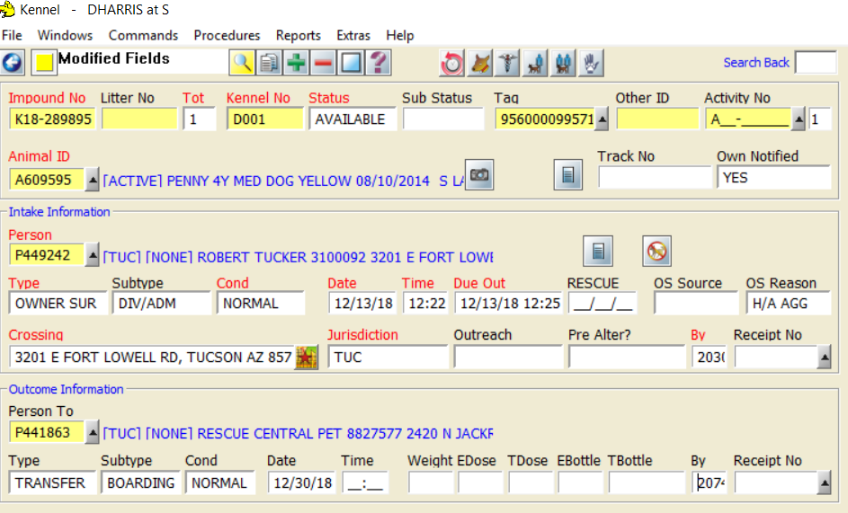

Stray with identification-Finder returning to owner
If we are able to get in contact with the owner and finder is willing to return to owner. Sign the pet in and outcome as RTO to owner. Please note: Subtype will be Div/Admin to track how many diverson adimssions has done.

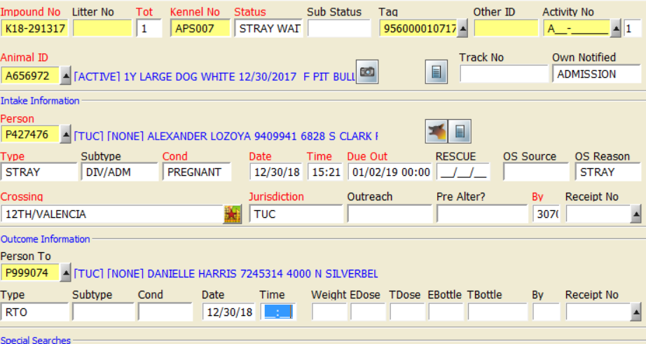

Stray-Transferring to rescue
If a stray comes in and a rescue makes commitment to come get the dog. We will sign the dog in and transfer to rescue. Please make sure rescue understand dog is still on stray hold. Please do not put in outcome date so pet still shows on Pet harbor. Kennel number should be changed to rescue. Please refer to rescue contact list to find possible rescue. You will need to call a couple and most likely leave message asking if they are interested in pet. Please note: Subtype will be Div/Adm to keep track of admissions diversions.

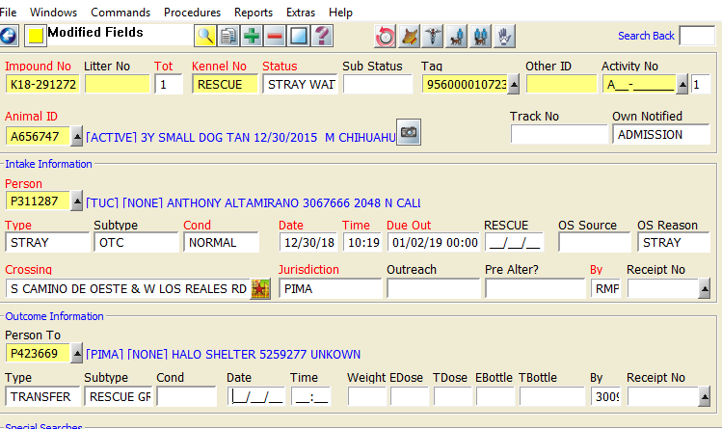

Stray-Finder taking back
If a stray comes in and the finder wants to hold onto the stray dog. Please provide the finder with an AWASA form to get the pet fixed if they choose to keep the pet or find it a home. Please note: Subtype will be Div/Admin to keep track of admissions diversions.

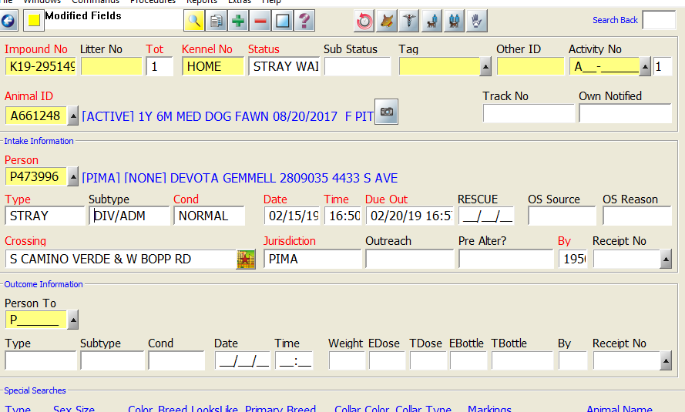

Owner surrender Diversion with tools
If an owner comes in to surrender pet and we are able to offer assistance (i.e. crate) for them to keep their pet. We will assign a# to the pet but not create impound Please make a note in Chameleon. We will log the tool we offered them here https://goo.gl/forms/pRPTKgea3dpCZMju2. We will log the A# and P# onto the spreadsheet so we can keep track of our diversions. Please also create P# if person is not already in Chameleon so that we can follow up with owner.

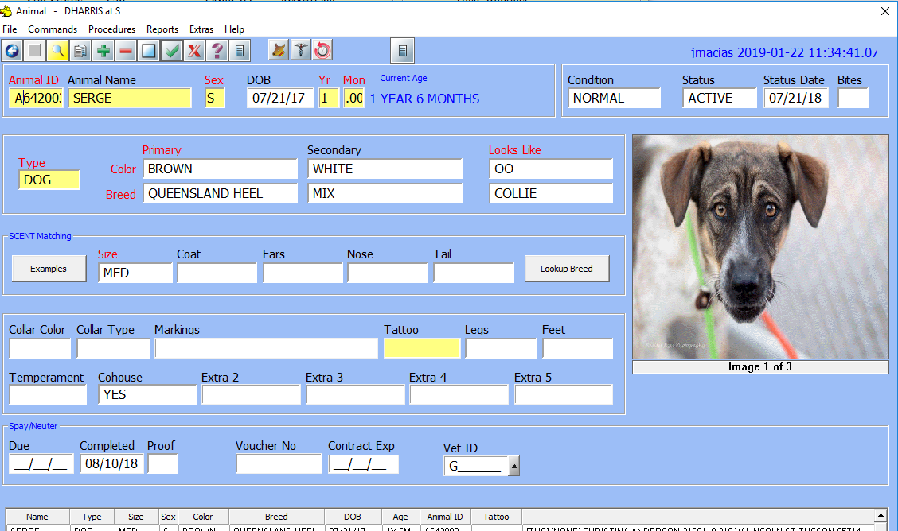

Owner surrender Diversion with medical assistance
If a person comes in to surrender their pet and we are able to offer medical assistance you will create a# and P# but not impound. Fill out diversion rubric template in A# and P# and template explaining what was offered to them and to what clinic. We will need to email appropriate clinic giving A# and how much we are offering in assistance. If pet is going to Pet Dr. please email petdoctorx@gmail.com or petdoctorfirstave@gmail.com also call and give them a heads up owner is on their way. If the pet is going to Santa Cruz you will need to email Rose@santacruzpet.com, Larmie@santacruzpet.com, info@santacruzpet.com, and have the owner call to make an appointment. We can only cover medical cost up to $500 dollars (please see sop for things covered). Please do not tell the owner we can cover up to $500. Please let owner know we can only cover some of the cost, and they may need to cover the rest. Please fill out the spreadsheet (on the counter upfront) with all the information to track diversion.

